Performance Analysis of a Three-Phase Induction Motor Using No-Load and Blocked-Rotor Tests
Subject: Electrical Machines — Electrical Engineering (Undergraduate)
SAMPLE — MODEL ASSIGNMENT · Prepared by RozContent Assignment Support as a demonstration sample for learning and quality review. Not for direct submission.

Abstract
This assignment analyses the performance of a 7.5 kW, 400 V, 50 Hz, four-pole, star-connected three-phase induction motor using the two classical laboratory tests: the no-load test and the blocked-rotor test. The per-phase equivalent circuit is developed from first principles, and the test measurements are used to extract its parameters: a stator resistance of 0.85 Ω, a referred rotor resistance of 0.63 Ω, leakage reactances of 1.80 Ω each, and a magnetising branch of 800 Ω in parallel with 52 Ω. Performance is then calculated at slips from 0.01 to 0.06. At the rated slip of 0.04 the motor delivers approximately 7.7 kW at 1,440 rpm with an efficiency of about 86% and a power factor of 0.89 lagging. The calculated breakdown torque is roughly 107 Nm, about twice the rated torque. The results confirm that these two simple tests predict the machine's complete operating behaviour with useful accuracy.

1. Introduction
The three-phase induction motor is the most widely used electric motor in the world. It is estimated that induction motors consume close to half of all electrical energy generated, driving pumps, fans, compressors, conveyors and machine tools in almost every industry. Their popularity rests on a simple and rugged construction — particularly the squirrel-cage rotor, which has no brushes, commutator or sliding contacts — together with low purchase cost, modest maintenance requirements and the ability to start directly from a three-phase supply (Chapman, 2012).
Because these motors are both numerous and energy-hungry, their efficiency, power factor, starting torque and overload capacity must be known before installation, and reference test values are needed so that deterioration in service is detected early. Manufacturers obtain these figures from a full test programme, but two short tests — the no-load test and the blocked-rotor test, standardised in IEEE Std 112 — already provide enough information to determine the equivalent-circuit parameters and hence to predict performance at any load (IEEE, 2017).
This assignment carries out that complete process for a small industrial motor whose nameplate data are given in Table 1. Section 2 reviews the construction and working principle, Section 3 develops the equivalent circuit, and Section 4 describes the two test methods. In Section 5 the parameters are extracted from the measurements and the performance is calculated over a range of slips. Sections 6 and 7 discuss and conclude the work.
Table 1: Nameplate data and specifications of the motor under test
Quantity | Value | Quantity | Value
Rated output | 7.5 kW | Rated voltage | 400 V (star)
Rated current | 15.2 A | Supply frequency | 50 Hz
Number of poles | 4 | Synchronous speed | 1,500 rpm
Rated speed | 1,440 rpm | Rated slip | 0.04
Rotor type | Squirrel cage | Enclosure / protection | TEFC, IP55
Insulation class | F | Duty | S1 (continuous)

2. Construction and Working Principle
The motor has two main parts: a stationary stator and a rotating rotor separated by a short uniform air gap, typically less than a millimetre in a machine of this size. The stator carries a three-phase distributed winding placed in slots of a laminated silicon-steel core. Laminating the core, and using silicon steel, reduces eddy-current and hysteresis losses respectively. When the winding is fed from a balanced three-phase supply, the three currents, displaced by 120° in time and space, produce a magnetic field of constant magnitude that rotates at synchronous speed (Hughes et al., 2019). For a machine with P poles supplied at frequency f, the synchronous speed is:
Ns = 120 f / P = (120 × 50) / 4 = 1,500 rpm
The squirrel-cage rotor consists of uninsulated aluminium or copper bars embedded in a laminated core and short-circuited at both ends by end rings, forming a closed cage. The rotating stator field sweeps past the rotor conductors and, by Faraday's law, induces electromotive forces in them. The resulting cage currents interact with the air-gap field to produce torque in the direction of the rotating field — in effect, the machine is a transformer whose secondary winding is free to rotate (Theraja and Theraja, 2005).
The rotor can never quite reach synchronous speed. If it did, there would be no relative motion between field and conductors, no induced current and therefore no torque. The rotor therefore settles at a speed N slightly below Ns, and the fractional difference is the slip:
s = (Ns − N) / Ns
At the rated speed of 1,440 rpm the slip is (1,500 − 1,440)/1,500 = 0.04. Slip is the central variable of induction-motor analysis: the frequency of the rotor currents is s·f (only 2 Hz at rated load), the rotor induced voltage is proportional to s, and the torque and efficiency at any operating point can all be expressed in terms of it.

3. Equivalent Circuit
Because the stator and rotor are coupled only magnetically, the machine can be analysed with the per-phase equivalent circuit of Figure 1, exactly as for a transformer, once all rotor quantities are referred to the stator. R1 and X1 are the stator winding resistance and leakage reactance. The magnetising branch, Rc in parallel with Xm, models the core loss and the magnetising current needed to establish the air-gap flux. The rotor branch contains the referred leakage reactance X2′ and the referred rotor resistance divided by slip, R2′/s (Fitzgerald, Kingsley and Umans, 2003).
Dividing the rotor resistance by slip is the key modelling device. The true rotor resistance R2′ accounts only for rotor copper loss; the additional component R2′(1 − s)/s represents the mechanical power developed, so one electrical circuit describes both the electrical and the mechanical behaviour. From the circuit, the air-gap power — the power transferred across the air gap — is the power absorbed in R2′/s:
Pg = 3 × I2′² × (R2′ / s)
and the electromagnetic torque follows directly, since torque is power divided by the synchronous angular velocity ωs = 157.08 rad/s:
T = Pg / ωs = (3 × I2′² × R2′ / s) / ωs
Rotor copper loss is s·Pg and the developed mechanical power is (1 − s)·Pg. Subtracting friction and windage losses and an allowance for stray load loss from the developed power gives the shaft output, and efficiency is the ratio of shaft output to electrical input. The circuit parameters used in this assignment, extracted from the tests in Section 5, are R1 = 0.85 Ω, X1 = 1.80 Ω, R2′ = 0.63 Ω, X2′ = 1.80 Ω, Rc = 800 Ω and Xm = 52 Ω per phase.
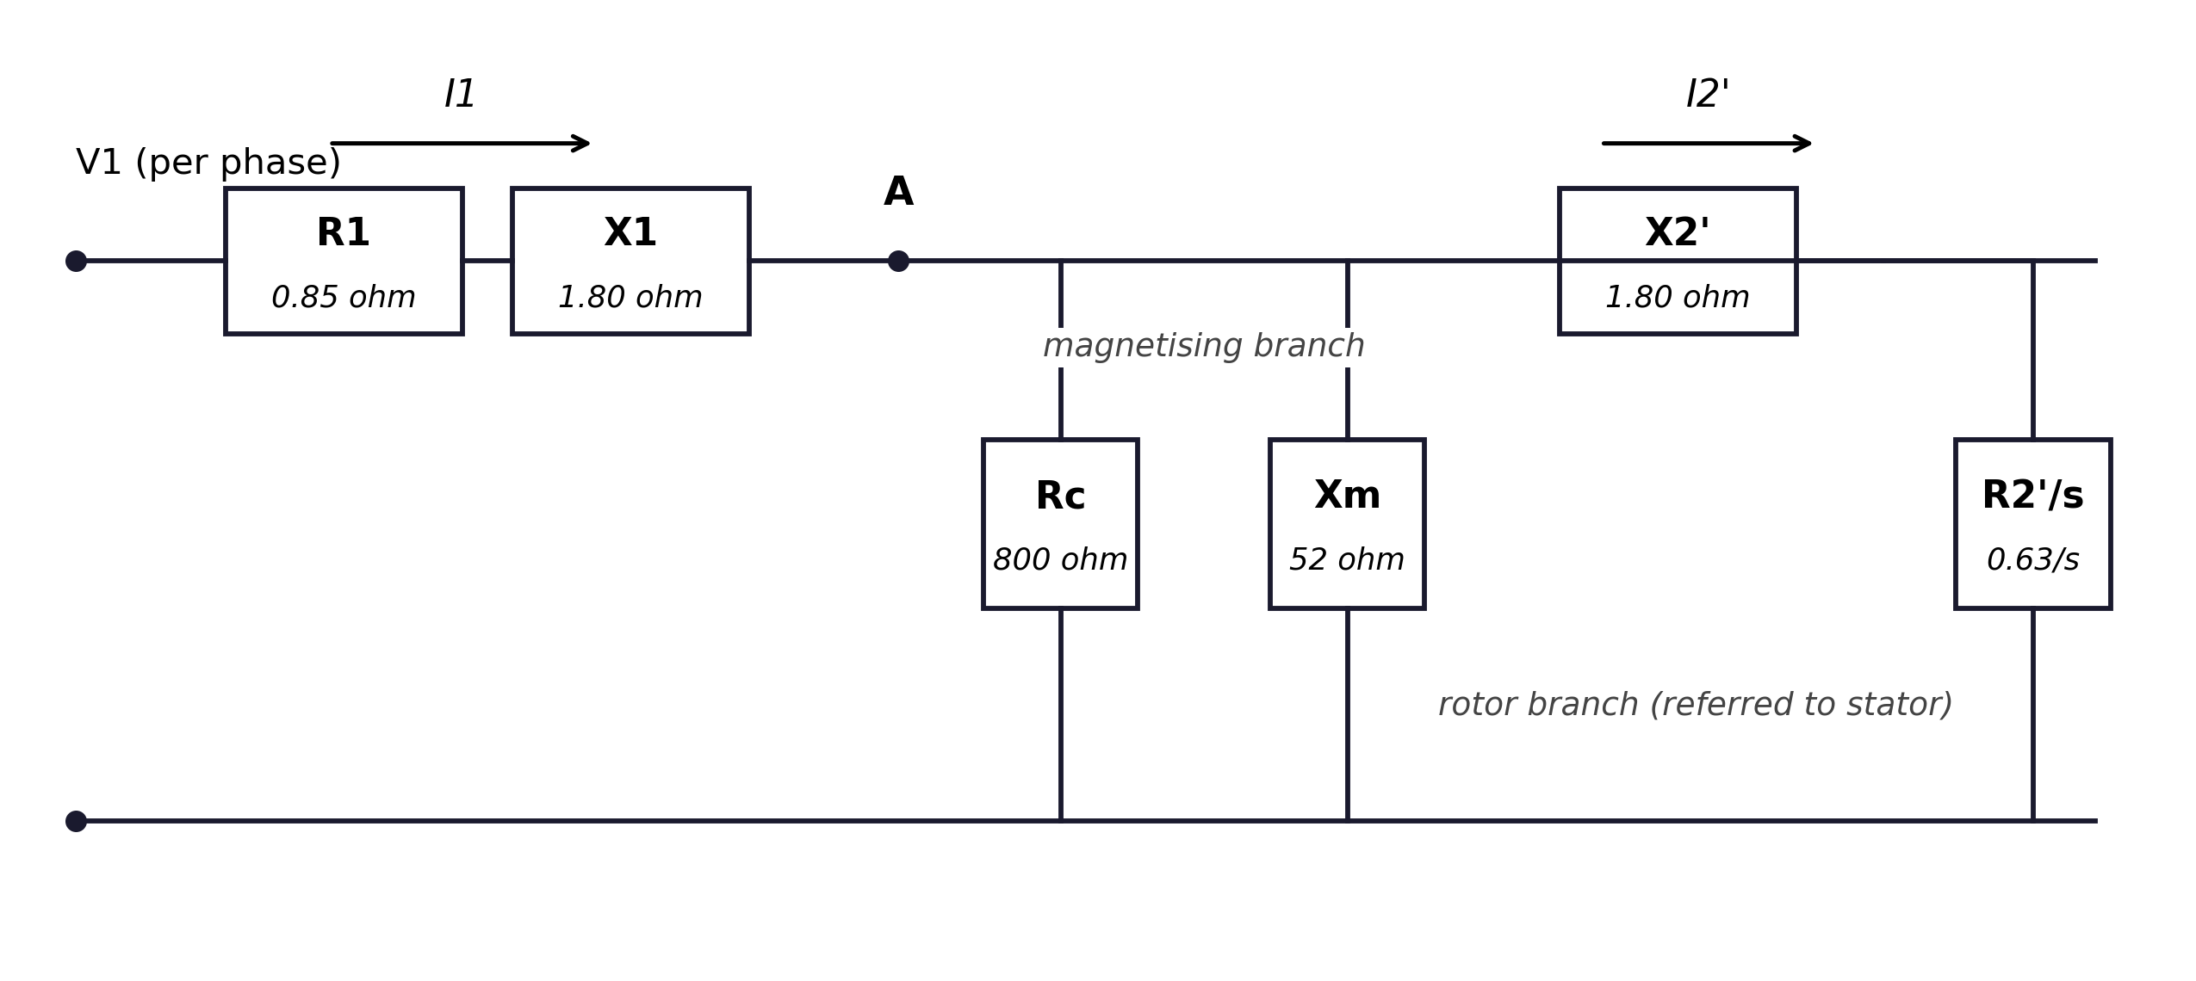
Figure 1: Per-phase equivalent circuit of the three-phase induction motor, with all rotor quantities referred to the stator.

4. Test Methods

4.1 No-Load Test
In the no-load test the motor runs uncoupled at rated voltage and frequency, so the slip is nearly zero and the rotor branch of the equivalent circuit is effectively open. The measured input power then supplies only the stator copper loss, the core loss and the rotational (friction and windage) losses, while the measured current is dominated by the magnetising component. The test therefore characterises the magnetising branch. Three quantities are recorded with the motor running steadily at rated voltage: line voltage, line current and total input power, the latter measured with the two-wattmeter method (IEEE, 2017). Repeating the test at several voltages and plotting input power (less stator copper loss) against voltage squared separates the rotational losses from the core loss by extrapolation to zero voltage, since speed is almost constant while core loss varies strongly with flux.

4.2 Blocked-Rotor Test
In the blocked-rotor (short-circuit) test the rotor is mechanically locked, so s = 1, and a reduced voltage from a variable supply is raised until the stator draws rated current. With the rotor stationary the low value of R2′/s makes the rotor branch carry almost all the current, and because the applied voltage is small the flux — and hence the core loss and magnetising current — is negligible. The test is therefore the induction-motor equivalent of the transformer short-circuit test, and it yields the total leakage reactance and the effective rotor resistance (Nagrath and Kothari, 2010). At standstill the rotor frequency equals the supply frequency, so skin effect in deep rotor bars raises the measured rotor resistance; IEEE Std 112 therefore recommends repeating the test at reduced frequency, commonly one quarter of rated, and correcting the results to obtain the resistance that applies at running slips.
Table 2: Measured results of the no-load and blocked-rotor tests
Quantity | No-Load Test | Blocked-Rotor Test
Applied line voltage (V) | 400 | 92
Line current (A) | 4.1 | 15.2
Total input power (W) | 520 | 1,850
Power factor | 0.18 lagging | 0.76 lagging
Rotor speed (rpm) | ≈ 1,498 | 0 (locked)
Slip | ≈ 0.001 | 1.0

5. Results and Calculations
Parameter extraction from the no-load test. The stator copper loss at no load is 3 × 4.1² × 0.85 = 43 W, leaving 520 − 43 = 477 W for core loss plus rotational losses. The voltage-extrapolation method of Section 4.1 assigns approximately 150 W to friction and windage, so the core loss at rated flux is about 327 W, represented in the circuit by Rc = 800 Ω at the internal air-gap voltage. The in-phase component of the no-load current is 520/(3 × 230.9) = 0.75 A, hence the magnetising component is √(4.1² − 0.75²) = 4.03 A, giving Xm ≈ 52 Ω after allowing for the small stator impedance drop. The no-load current of 4.1 A is 27% of rated current and its power factor is only 0.18, both typical of a healthy small induction motor.
Parameter extraction from the blocked-rotor test. The per-phase equivalent impedance at standstill is (92/√3)/15.2 = 3.49 Ω, the equivalent resistance is 1,850/(3 × 15.2²) = 2.67 Ω, and the equivalent leakage reactance is √(3.49² − 2.67²) = 2.25 Ω. The resistance figure is inflated by skin effect at 50 Hz rotor frequency, as explained in Section 4.2; the reduced-frequency repeat test gives the running values used in the calculations, R2′ = 0.63 Ω with X1 + X2′ = 3.60 Ω, split equally between stator and rotor. The stator resistance R1 = 0.85 Ω was measured directly with a DC bridge and corrected to a 75 °C operating temperature.
Calculated performance. Using these parameters in the exact equivalent circuit, with friction and windage of 150 W and a stray-load-loss allowance of 50 W, gives the performance in Table 3. At the rated slip of 0.04 the model predicts a line current of 14.4 A, a torque of 52 Nm and an output of about 7.7 kW — close to the 7.5 kW, 1,440 rpm nameplate point. The torque–slip curve computed from the same model is shown in Figure 2, and Figure 3 plots efficiency and power factor against output power using the Table 3 values.
Table 3: Calculated performance of the motor at different slips (exact equivalent circuit; friction and windage 150 W, stray load loss 50 W)
Slip, s | Rotor speed (rpm) | Torque (Nm) | Output power (kW) | Efficiency (%) | Power factor
0.01 | 1485 | 14.7 | 2.08 | 81.0 | 0.646
0.02 | 1470 | 28.3 | 4.16 | 86.5 | 0.821
0.03 | 1455 | 40.9 | 6.03 | 87.1 | 0.873
0.04 | 1440 | 52.2 | 7.67 | 86.2 | 0.889
0.05 | 1425 | 62.3 | 9.09 | 84.9 | 0.892
0.06 | 1410 | 71.1 | 10.30 | 83.4 | 0.887

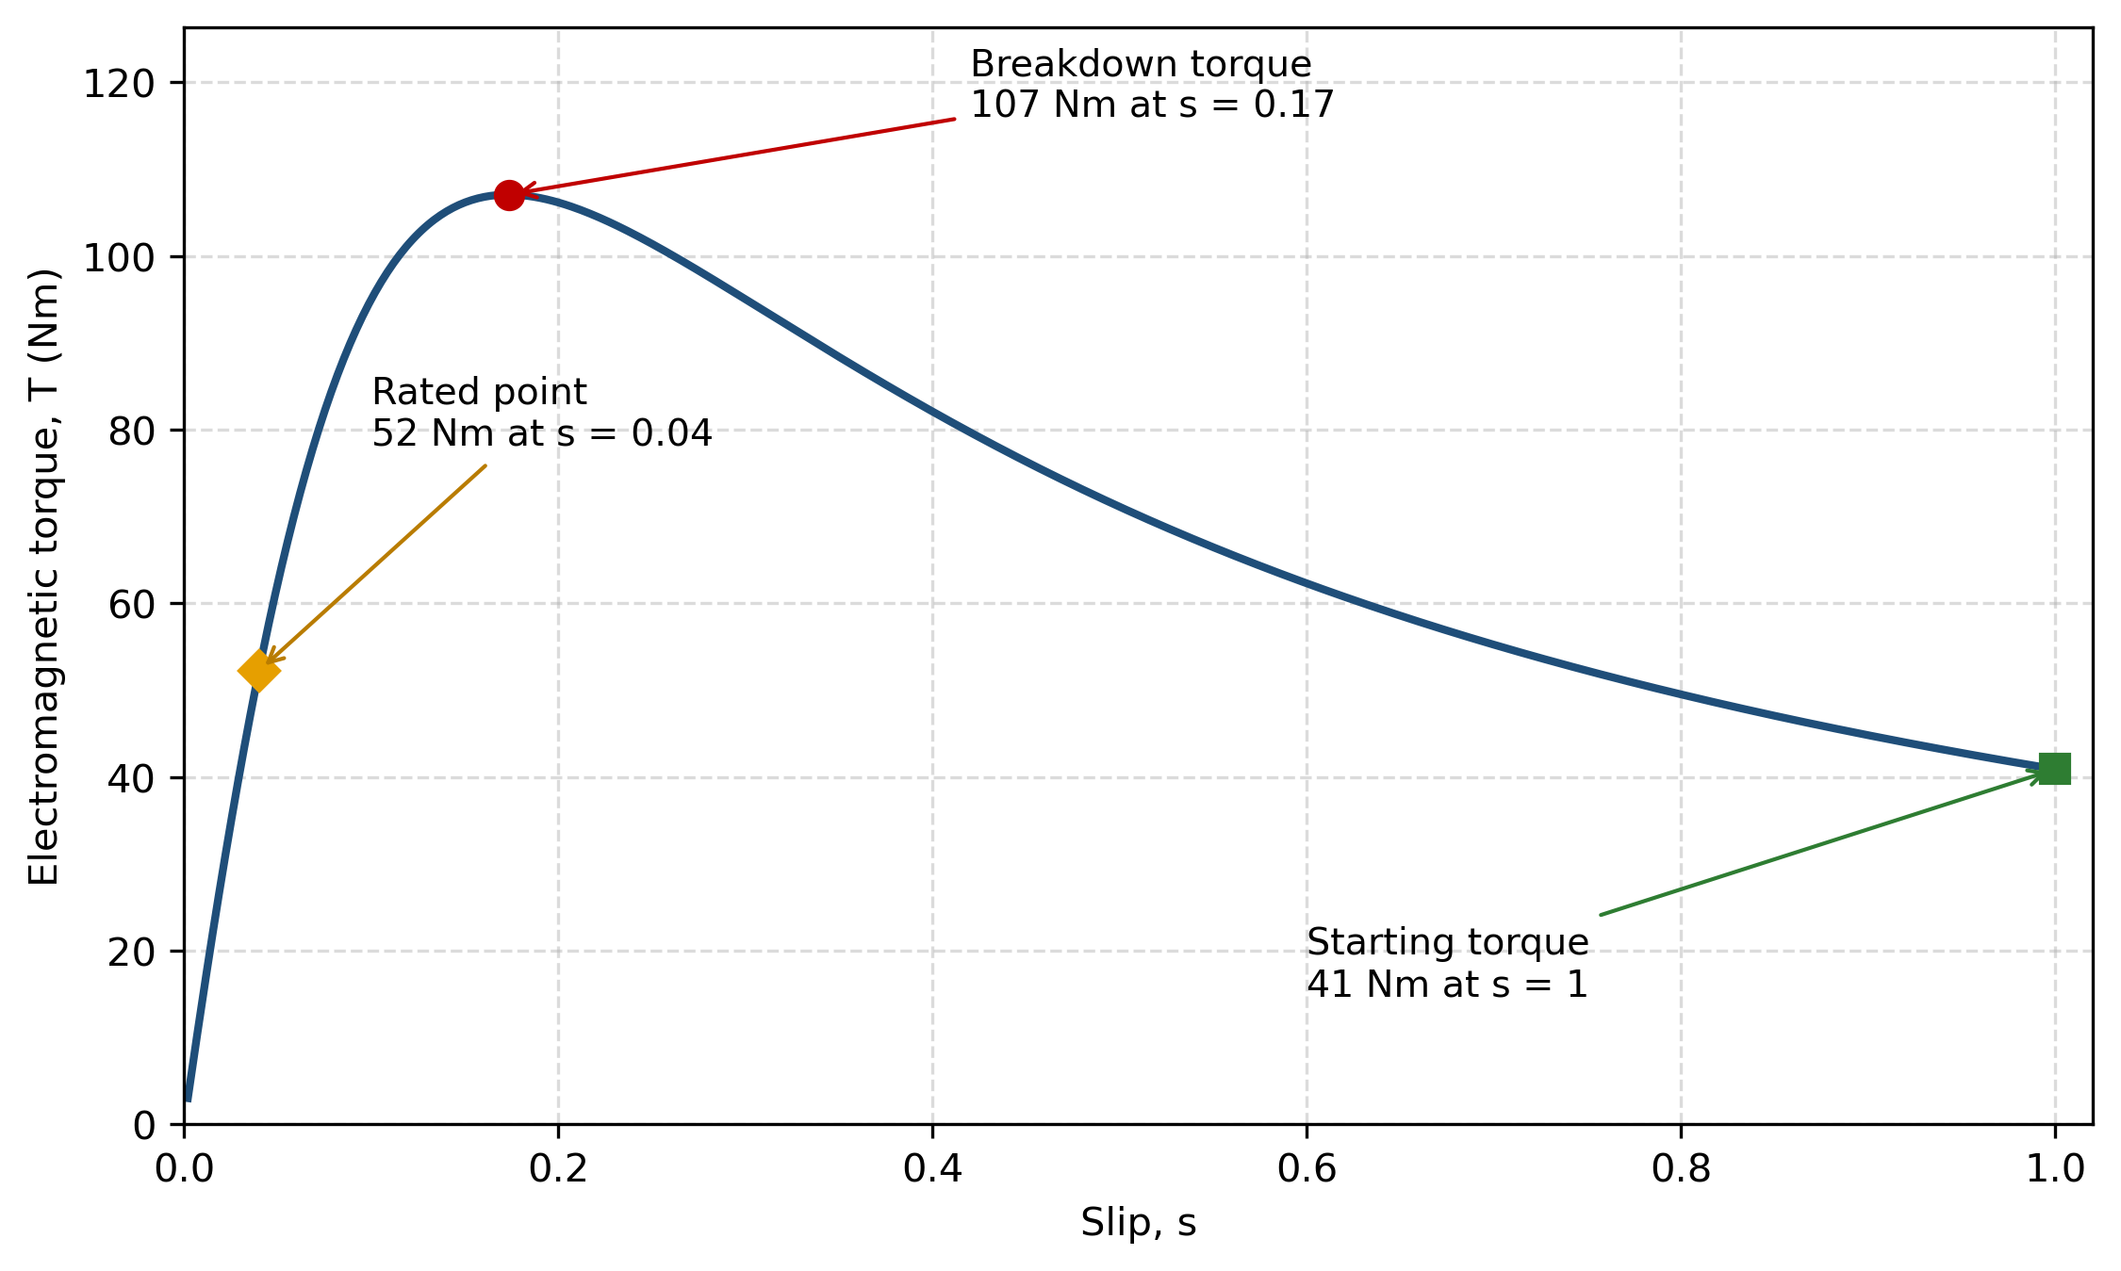
Figure 2: Torque–slip characteristic of the motor, computed from the equivalent circuit of Figure 1.
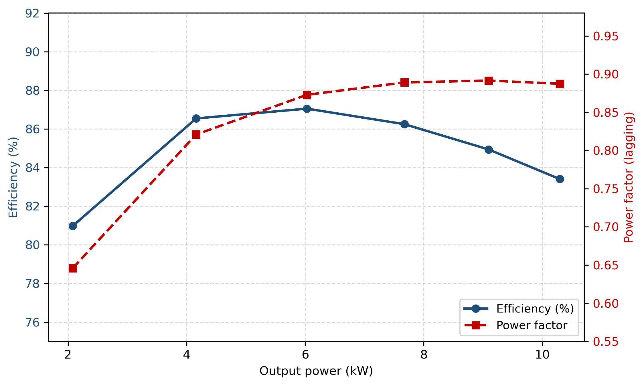
Figure 3: Efficiency and power factor versus output power, from the calculated results of Table 3.

6. Discussion
The results display all the classical features of induction-motor behaviour. Starting torque, at 41 Nm, is about 0.8 times the rated torque, while the breakdown (maximum) torque of 107 Nm at a slip of 0.17 is roughly twice rated torque, so the motor tolerates short-lived overloads without stalling. Between no load and rated load the speed falls by only 60 rpm (4%), which is why the induction motor is regarded as an essentially constant-speed drive. Efficiency rises quickly with load, peaks close to the rated point at about 87%, and falls again at slips above 0.04 because rotor copper loss grows in direct proportion to slip. The power factor behaves as expected: a poor 0.65 at light load, where the magnetising current is a large fraction of the total, improving to 0.89 at rated load (Figure 3).
Two limitations of the model should be recognised. First, the constant-parameter circuit underestimates starting torque, because at standstill the rotor frequency is 50 Hz and skin effect in the cage bars raises the effective rotor resistance — the same effect noted in the blocked-rotor test — which increases starting torque while reducing starting current in a real machine. Second, the calculation assumes the parameters are independent of temperature and saturation; in practice the winding resistance rises by roughly 0.4% per °C and the magnetising reactance falls as the teeth saturate. Even so, the predicted rated point (7.7 kW, 14.4 A, 86%) agrees with the nameplate values (7.5 kW, 15.2 A) within a few percent — a full performance prediction from measurements that take minutes and need no loading machinery.

7. Conclusion
The no-load and blocked-rotor tests were applied to a 7.5 kW three-phase induction motor and used to determine its equivalent-circuit parameters. From those parameters the complete performance was predicted: at rated slip the motor produces about 7.7 kW at 1,440 rpm with an efficiency of approximately 86% and a power factor of 0.89 lagging, with a breakdown torque near 107 Nm and a starting torque near 41 Nm. The predicted values agree closely with the nameplate data, confirming that the two classical tests, interpreted through the equivalent circuit, give a reliable and economical assessment of induction-motor performance. The same procedure, repeated periodically, provides an effective condition-monitoring tool, since changes in the measured values reveal problems such as damaged rotor bars or deteriorating insulation long before failure occurs.

References
Chapman, S. J. (2012). Electric Machinery Fundamentals (5th ed.). McGraw-Hill.
Fitzgerald, A. E., Kingsley, C., Jr., & Umans, S. D. (2003). Electric Machinery (6th ed.). McGraw-Hill.
Hughes, E., Hiley, J., Brown, K., & McKenzie Smith, I. (2019). Hughes Electrical and Electronic Technology (12th ed.). Pearson.
IEEE. (2017). IEEE Standard Test Procedure for Polyphase Induction Motors and Generators (IEEE Std 112-2017). IEEE.
Nagrath, I. J., & Kothari, D. P. (2010). Electric Machines (4th ed.). Tata McGraw-Hill.
Theraja, B. L., & Theraja, A. K. (2005). A Textbook of Electrical Technology: Vol. 2 — AC and DC Machines. S. Chand.

